Visual Literacy in Mathematics
by Lee Alan H. Roher, Ed.D.
Visual literacy in mathematics does not just consists of reading word problems and converting them into equations, or examining tables and graphs to decipher the numerical representations but we have an entire library of mathematical symbols that have meaning in diagrams. Some of these symbols are known in the general population. For example, the degree symbol for temperature: 79°. This degree symbol is used for temperature measured in both Fahrenheit and Celsius as well as represents the degree measure of an angle. And I think that the little square box in an angle is recognized by most to represent a right angle.

Right Angle Symbol

There are symbols that are used in diagrams to represent parallel lines, congruent sides, and congruent angles. If you look at the diagram above the arrow on the vertical sides of the rectangle denote parallel lines. The ticks on the horizontal sides represent congruent lines or lines that have the same and measure. The diagonal of the rectangle forms two triangles. The ticks on this diagonal represent the reflexive property. This one line is used to make both triangles and this one line is equal to itself. Using visual literacy, the above diagram shows the markings of two congruent triangles using the hypotenuse-leg theorem.
It is important in mathematics that one does not assume anything from a diagram other than what is explicitly marked. Even though the reader may think something makes sense or is reasonable an idea cannot be used unless it is marked appropriately in the diagram or proven with logical thoughts using postulates and theorems.
In Algebra 2 and in College Algebra, I consider visual literacy to include recognition of equations and graphs to particular function families. The Algebra 2 student should be able to identify a function by looking at a graph and recognizing the similarities to the parent function. The student should then be able to discern the parameters used to change or manipulate the graph. Likewise, the student should be able to look at the format of a given function and identify the particular function family.
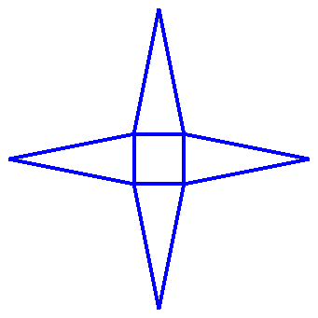
Nets are two-dimensional diagrams that represent three-dimensional figures. Another type of literacy is the ability to look at the net and mentally recognize the three-dimensional figure. Some students may need to develop this knowledge by cutting out the nets and physically manipulating the net into the figure. They can practice this exercise until they see the pattern of how the nets are put together. Below is an example of a net that makes a pyramid.
Net Pyramid

In addition to these examples of visual literacy in mathematics, we have our charts and graphs models, like a circle graph, that students should be able to read and understand. mathematical visual literacy include is not limited to the ability to read, understand and translate, verbal models, expressions, equations and inequalities, graphs and charts, and diagrams.
Students and people in general need to be able to see mathematical texts in any form and understand what the author is trying to state.

