UbD Exhange Website

www.ubdexchange.org/

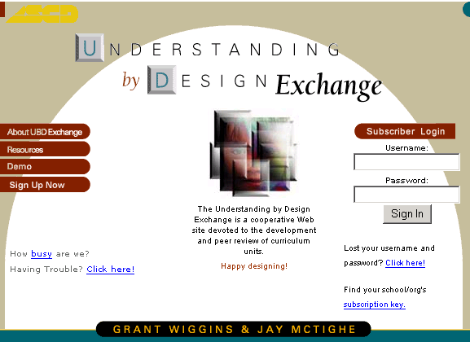

Sign up now!!! ☺

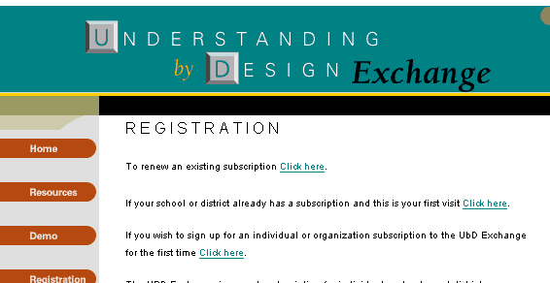

Jessamine County’s Subscription code
ubdjcounty9

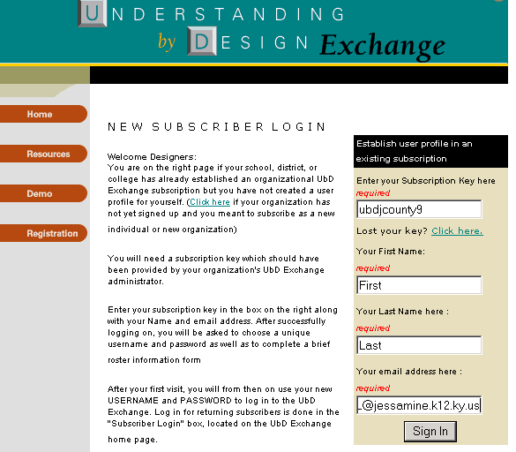

Sign in…

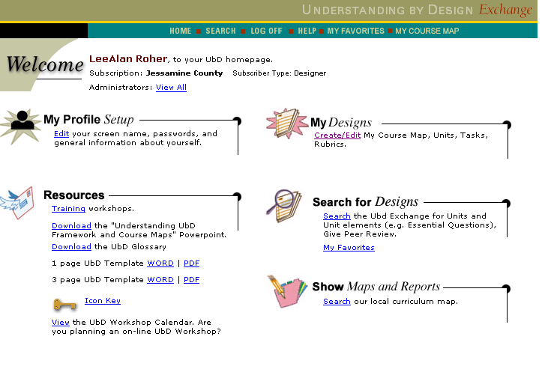

Work on your courses

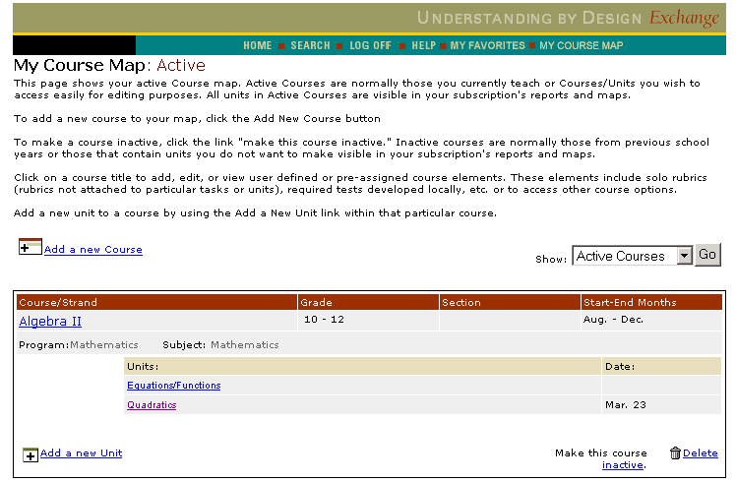

Add new course

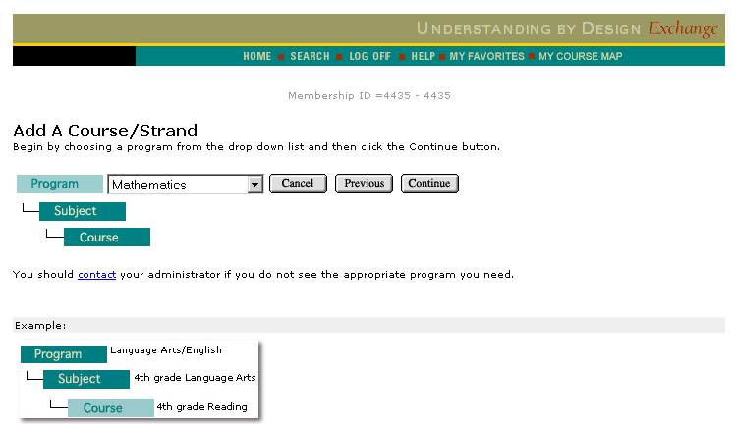

Must click continue to get to subject

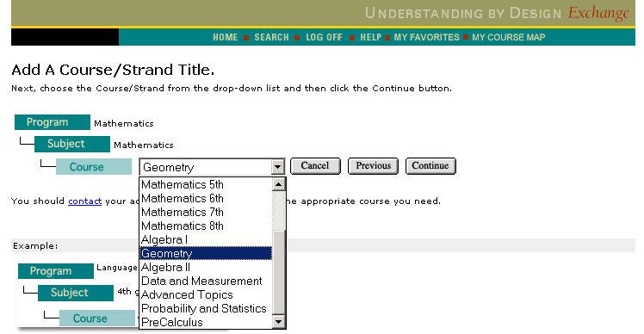

Select your course

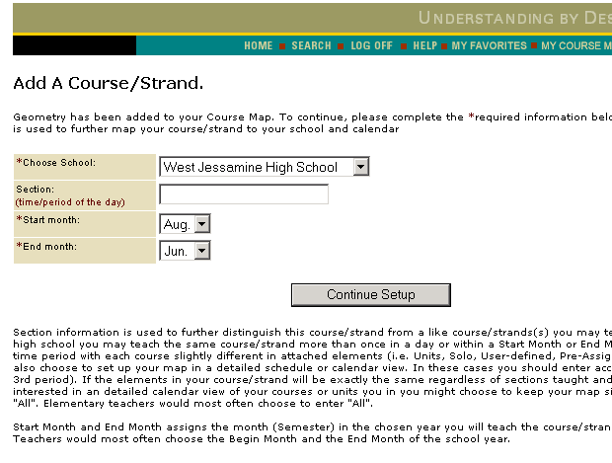

Select your school and course dates

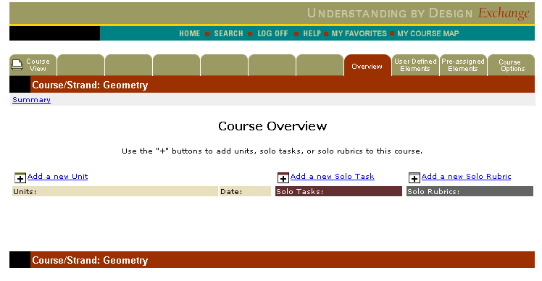

Add a new Unit

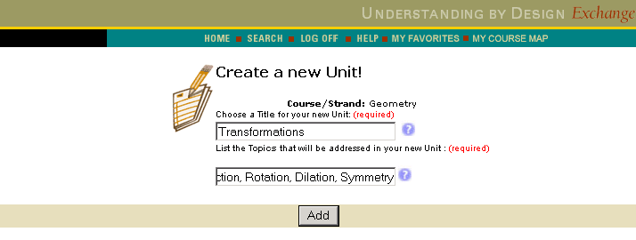

(Required)

Overview & Status
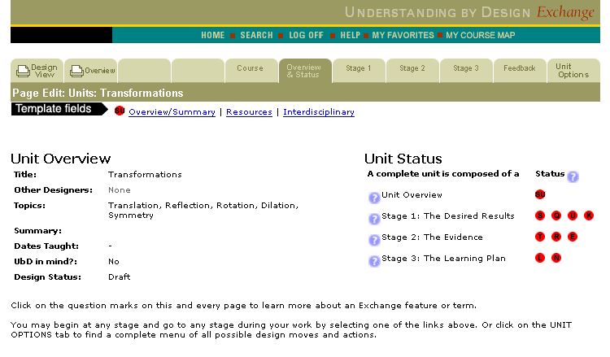

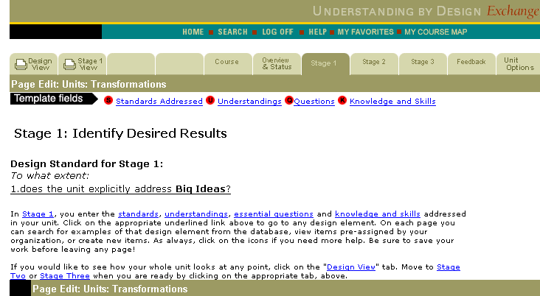
STAGE 1: Standards, Understanding, Essential Questions, Knowledge and
Skills

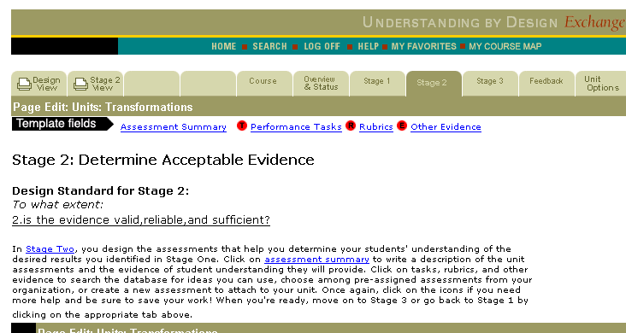
STAGE 2: Assessment Summary, Performance
Tasks , Rubrics, Other Evidence

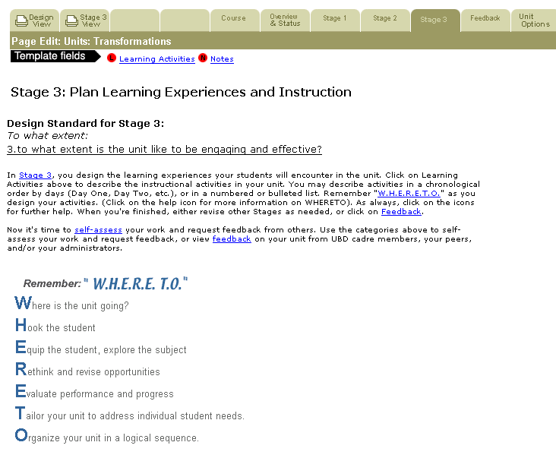
STAGE 3: Standards, Understanding, Essential Questions, Knowledge and Skills

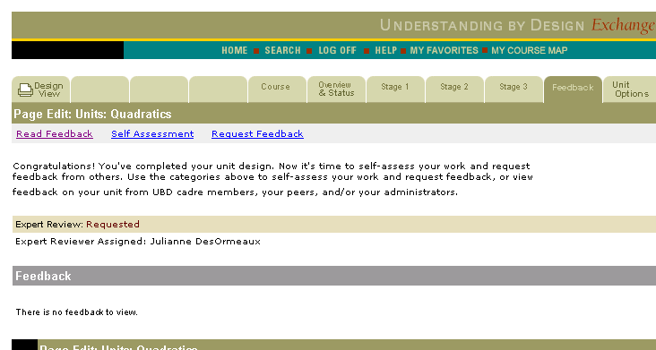
Feedback:
Check this page
for Expert Reviewer’s Comments

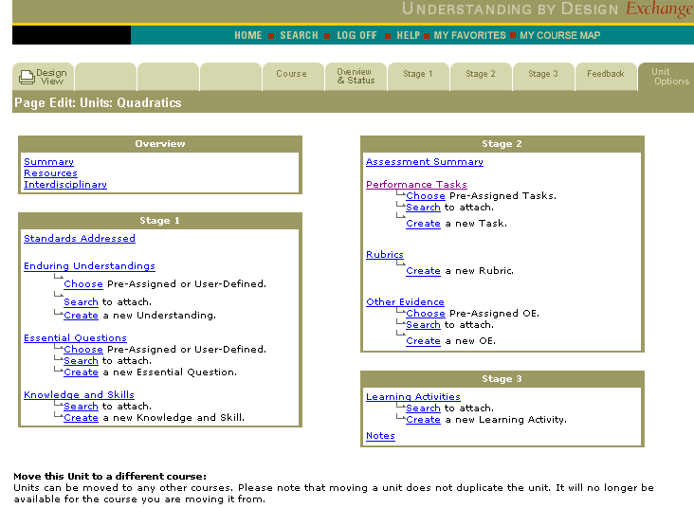
Unit Options:
Links to all parts
of the unit.

